Solubility Worksheet
- Name three factors that influence the rate at which a solute dissolves in a solvent

- Define the following words

- Solubility

- Saturated
- Unsaturated

- Supersaturated

The graph below contains solubility curves and can be used to determine if a particular solution is saturated at a given set of conditions and how much of the solute is dissolved under those conditions.
Whenever you are given a graph to analyze the first thing you should do is look at each axis to determine what information the graph is showing.
X- axis – ___________________________ Y-axis – __________________________
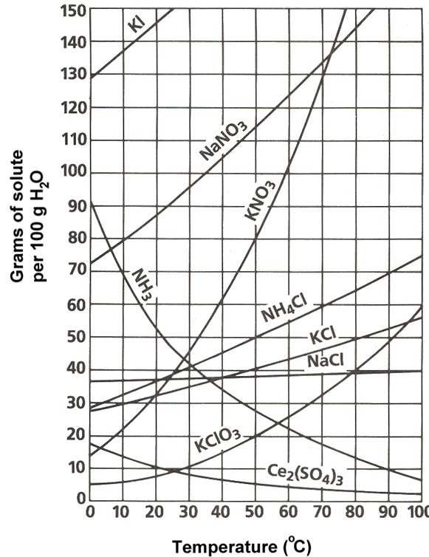
Each line represents the maximum amount of solute that can be dissolved in 100 g of H₂O at a particular temperature to make a saturated solution.
- Below the line = the solution is __________
- On the line = the solution is __________
- Above the line and all the solute is dissolved = the solution is ____________
For most substances, solubility increases as temperature increases. What are the exceptions on the graph below? ______________________________________
Part One: Reading Solubility Curves
Use the graph to answer the following questions. REMEMBER UNITS!
- What mass of solute will dissolve in 100 g of water at the following temperatures?
  - KNO₃ at 70°C ____________
  - NaCl at 100°C ____________
  - NH₄Cl at 90°C ____________
  - Which of the above three substances is most soluble in water at 15°C. ____________
Part Two: Types of Solutions (saturated, unsaturated, supersaturated)

On a solubility curve, the lines indicate the concentration of a __________________ solution - the maximum amount of solute that will dissolve at that specific temperature.

Values on the graph ____________ (below, above, on) a curve represent unsaturated solutions - more solute could be dissolved at that temperature.

Use the solubility curve on the second page to label the following solutions as supersaturated, saturated or unsaturated. If unsaturated, write how much more solute can be dissolved in the solution.
Solution | Supersaturated, Saturated or Unsaturated? | If unsaturated: How much more solute can dissolve? | Concentration of the solution in M (moles/ltre)
a solution that contains 70g of NaNO₃ at 30°C (in 100 mL H₂O)

a solution that contains 50g of NH₄Cl at 50°C (in 100 mL H₂O)

a solution that contains 20g of KClO₃ at 50°C (in 100 mL H₂O)

a solution that contains 30g of KClO₃ at 40°C (in 100 mL H₂O)

Additional Practice:
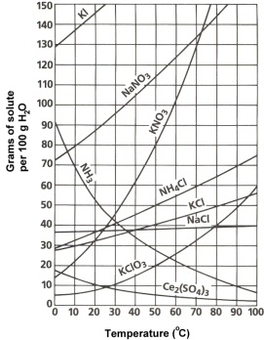
1. At 30°C, you dissolved 90 g of KCl in 300 g of water. Is this solution supersaturated, saturated or unsaturated?
2. A mass of 100 g of NaNO₃ is dissolved in 100 g of water at 80ºC.
a) Is the solution supersaturated, saturated or unsaturated? ______________________________
b) As the solution is cooled, at what temperature should solid first appear in the solution? Explain.
3. Use the graph to answer the following two questions:
Which compound is most soluble at 20 ºC? ________
Which is the least soluble at 40 ºC? ________
4. Which substance on the graph is least soluble at 10°C? _______
5. A mass of 80 g of KNO₃ is dissolved in 100 g of water at 50 ºC. The solution is heated to 70ºC. How many more grams of potassium nitrate must be added to make the solution saturated? Explain your reasoning

